Summary
In many games, scoring helps provide feedback and motivation to players. In this tutorial, you'll add a basic scoring system to your game that tracks how long the player survives and displays their score on the screen using Unity's UI Toolkit system.
1. Overview
Q&A (0)
In many games, scoring helps provide feedback and motivation to players. In this tutorial, you'll add a basic scoring system to your game that tracks how long the player survives and displays their score on the screen using Unity's UI Toolkit system.
Play Video
Mark step incomplete
2. Track elapsed time
Q&A (0)
To begin calculating a score, you first need to measure how long the player has been alive. Unity provides a helpful built-in value called Time.deltaTime, which returns the time in seconds since the last frame. By adding this value to a running total each frame, we can track how long the player has survived — regardless of frame rate. In this step, you’ll implement this timer inside your PlayerController script.
Play Video
1. Declare a variable to store elapsed time:
- Open your PlayerController script.
- Near the top of the class (after your other variable declarations), add the following line of code:
private float elapsedTime = 0f;
Note: Writing private is not required — Unity automatically treats variables as private if you don’t specify them as private or public. Still, it’s a good habit to include private explicitly. This makes your code easier to understand by clearly showing which variables are private and which are public.
2. Increment elapsed time using Time.deltaTime:
- Inside the Update() method, add the following line of code at the top:
elapsedTime += Time.deltaTime;
Explanation:
- += is a shorthand for "add to this variable."
  - elapsedTime += Time.deltaTime; is the same as writing: elapsedTime = elapsedTime + Time.deltaTime;
- Time.deltaTime is the time (in seconds) since the last frame.
- If you add that small number every frame, it adds up over time. The result is a running total of how much time has passed since the game started — this works no matter what the frame rate is.
3. Log the result in the Console window:
- Below the line you just added, add the following line of code:
Debug.Log("Elapsed time: " + elapsedTime);
4. Test and observe the Console window:
- Save the script, return to Unity, and enter Play mode to test.
- Watch the Console window to see the timer increase over time.
- Let the Player GameObject collide with an obstacle and notice that the log stops. This script is attached to the Player GameObject, so when it gets destroyed — the timer stops because the script is no longer in the scene.
Your game now tracks how long the player survives using Time.deltaTime.
Mark step incomplete
3. Add a score multiplier
Q&A (0)
Now that you’re tracking how long the player has survived, it’s time to turn that into a score. It wouldn’t be very interesting if the score just went up by 1.0 every second.
In this step, you’ll create two new variables: one to hold the final score and one to define a score multiplier. Then, you’ll display that score using Debug.Log.
Play Video
1. Declare the score and multiplier variables:
- In the PlayerController script, add the following lines of code near your other variables:
private float score = 0f;
public float scoreMultiplier = 10f;
Note: You might want the score multiplier to be public if you want to adjust it in the Inspector window later.
2. Calculate the score in Update():
- Just below where you update elapsedTime, add the following line of code:
score = elapsedTime * scoreMultiplier;
3. Log the score to the Console window:
- Replace the existing Debug.Log line with the following line of code:
Debug.Log("Score: " + score);
Explanation:
- This Debug.Log line will display the score instead of the elapsed time.
4. Test and observe the console:
- Save the script, return to Unity, and enter Play mode to test.
- Watch the Console window to see the score increase over time.
Because both values are floats, your result will include decimal points (for example, Score: 17.32647). Don’t worry — you’ll round that value to an integer in the next step.
Mark step incomplete
4. Round the score to an int
Q&A (0)
Right now, the score displays as a long decimal number, which can be hard to read and doesn’t feel very game-like. Most games use whole numbers for score displays. In this step, you’ll use Mathf.FloorToInt(), a Unity function that rounds a decimal number down to the nearest whole number. You’ll also learn what an int is and why you’d use it instead of a float when displaying clean numbers.
Play Video
1. Round the score using Mathf.FloorToInt():
- Replace the line where you calculate the score with the following line of code:
score = Mathf.FloorToInt(elapsedTime * scoreMultiplier);
Explanation:
- An int is a whole number (like 0, 1, 25). It doesn’t store decimal places.
- Mathf.FloorToInt() takes a decimal (float) and returns the largest whole number less than or equal to that value.
- For example: Mathf.FloorToInt(3.7f) gives 3.
- This ensures the score only increases after full seconds have passed — which is useful if, for example, you want the player to earn 1 point per second of survival.
- Without flooring, a score like 3.7 would round up to 4, giving credit before the full second has actually passed.
2. Test and observe the Console window:
- Save the script, return to Unity, and enter Play mode to test.
- Watch the Console window to see the score increase over time.
The Console window should display clean whole numbers like Score: 47, instead of Score: 47.39214.
Mark step incomplete
5. Set up a UI document
Q&A (0)
Now that the score is being calculated correctly, it’s time to display it on the screen. In Unity, you can create user interfaces using the UI Toolkit, which uses assets called Panel Renderer written in UXML (a markup language similar to HTML). This step walks you through creating a Panel Renderer and connecting it to your scene so you can begin building a heads-up display (HUD) for your score.
A Panel Renderer component references a UXML document and a Panel Settings asset. It serves as a bridge between the Scene and a UXML document. The UXML document specifies the UI structure, while the Panel Settings asset handles rendering.
1. Create a Panel Renderer GameObject in the scene:
- Create an Empty GameObject in the scene.
- Rename the new GameObject “GameUI”.
- Right-click the UI folder and select Create > UI Toolkit > Panel Renderer.
In the inspector, click on “New” to create a new UXLTemplate.
Mark step incomplete
6. Add the score label
Q&A (0)
With the UI container set up in your scene, the next step is to design the actual interface that’ll display your score. You’ll do this using the UI Builder window, a drag-and-drop editor for creating UI layouts visually. In this step, you’ll add a Label, give it a clear name, and set some placeholder text.
Play Video
1. Open the UILayout asset in UI Builder:
- In the Project window, double-click the UILayout asset you created earlier.
- This opens the UI Builder window, which contains a live Viewport window (similar to the Scene view), a Library window (similar to the Project window), a Hierarchy window, and an Inspector window, just like the Unity Editor.
2. Add a Label to the UI:
- From the Library window (usually on the left), drag a Label element into the Hierarchy window.
- You’ll now see a text label appear in the Viewport window that says Label by default.
3. Rename the Label to ScoreLabel:
- In the Hierarchy window of the UI Builder window, select the new Label element.
- In the Inspector window (on the right), rename the Label element by setting its name at the very top of the Inspector panel to “ScoreLabel”.
  - Spelling is important here — you’ll use this name in your script to reference the label later.
- In the Attributes section, in the Text box, change the placeholder text to “Score: 0”.
4. Save and preview your changes:
- Press Ctrl+S (macOS: Cmd+S) to save the UILayout asset.
- You can now close or minimize the UI Builder window.
Back in the Unity Editor, you will see the “Score: 0” text appear in the upper left corner of the screen, though it may be hard to see against a dark background — you’ll fix that next.
Mark step incomplete
7. Style the label
Q&A (0)
By default, UI elements added in UI Builder are small, plain, and usually tucked in the upper-left corner. In this step, you’ll center the label horizontally and give it some visual breathing room using inlined styles — direct style settings applied to individual UI elements.
Play Video
1. Reopen the UILayout in UI Builder (if closed):
- In the Project window, double-click the UILayout asset to reopen it in the UI Builder window.
Tip: If the Viewport window looks zoomed or misaligned, select Fit Viewport at the top of the window to recenter it.
2. Select the ScoreLabel in the UI Hierarchy panel:
- In the Hierarchy window, select the ScoreLabel element you created earlier.
3. Apply basic layout styling:
- In the Inspector window on the right side, expand the Inlined Styles section.
- Under Position, set the Top Offset to around 20px (pixels). This will move the score down a bit so it’s not overlapping the top border wall.
- Under Align > Align Self, select Center to center the label horizontally.
4. Adjust the font and text color:
- In the Text section of the Inlined Styles section, try the following changes:
  - Set Font Size to something like 20.
  - Select a Color that contrasts well with your background.
  - Optionally, add Font Style like Bold if you want the score to stand out.
- Press Ctrl+S (macOS: Cmd+S) to save the UILayout asset and return to the Unity Editor to preview your score UI formatting.
After this step, the ScoreLabel should be clearly visible, centered near the top of the screen, and easy to read.
Mark step incomplete
8. Get a reference to the UI document
Q&A (0)
Before your script can update the score label, it needs to access the UI that’s visible in the scene. To do that, you’ll get a reference to the UI Document component attached to your GameUI GameObject.
Play Video
1. Add a variable for the UI Document:
- Open your PlayerController script.
- Near your other variable declarations, add the following line of code:
[SerializeField]
private PanelRenderer panel;

[SerializeField]
private VisualElementReference<Label> labelReference;

2. Fix the missing reference error:
- If PanelRenderer is underlined or causes an error, add the following line of code to the top of your script:
using UnityEngine.UIElements;
Note: This line gives your script access to Unity’s UI Toolkit classes. If you're using autocomplete in your IDE, it may have already added this line for you automatically.
3. Assign the PanelRenderer in the Inspector window:
- Save your script and return to the Unity Editor.
- With the Player GameObject selected, in the Inspector window, locate the PanelRenderer property that now appears in the PlayerController component.
Note: You must assign the GameObject from the scene, not the UILayout UXML asset from the Project window.
After this step, your script has access to the UI and is ready to find and modify specific elements inside it.
Mark step incomplete
9. Set the score text with true score
Q&A (0)
Now that your script can access the UI document in the scene, the next step is to find the score label inside it and update its text.
Play Video
1. Add a variable to reference the label:
- In your PlayerController script, add the following line of code with your other variables:
private Label scoreText;
Note: A Label is the specific UI Toolkit class used for displaying text. This line prepares a variable to hold the reference to the ScoreLabel UI element.
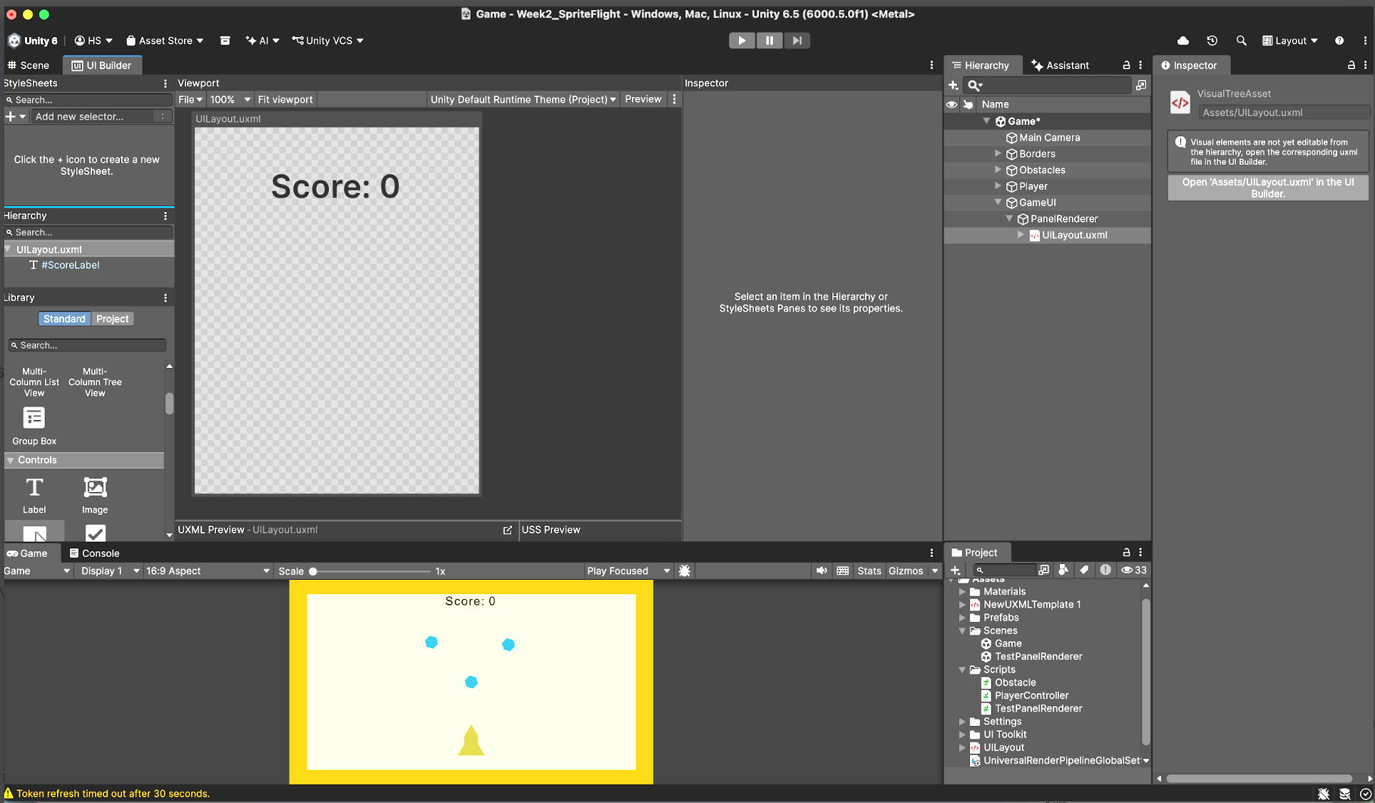

10. Scale with screen size
Q&A (0)
The score label looks fine on your current screen, but if you resize the Game view or change aspect ratios, it might shift or appear too small. With these settings in place, if someone plays your game on a huge high resolution monitor or on a small low resolution phone, the UI could change in unexpected ways. To address this, you’ll adjust the Panel Settings so your UI scales automatically with the screen. This is an easy way to ensure your UI remains readable and correctly positioned on any resolution or device.
Play Video
1. Experiment with different Game view resolutions:
- In the Game view, use the aspect ratio dropdown to select a few different screen resolutions.
- Notice that the score text gets smaller and changes position at higher resolutions.
2. Select the Panel Settings asset:
- In the Project window, locate the Panel Settings asset that was automatically created when you added the UI Document to the scene. It’s usually inside a folder called UI Toolkit or next to your UILayout asset.
Tip: You can search the entire Assets folder using the search bar.
3. Set it to scale with the screen size:
- With the Panel Settings asset selected, in the Inspector window, set the Scale Mode property to Scale With Screen Size.
4. Adjust the reference resolution if needed:
- If the UI elements became smaller or larger than you’d like, under the Scale Mode Parameters section, increase or decrease the Reference Resolution Width and Height properties.
After changing this setting, test different Game view aspect ratios from the dropdown in the Game view or by dragging the top edge of the Game view up and down. The score label should now stay anchored and readable regardless of window size.
Mark step complete
11. Final script sample
Q&A (0)
If you have any errors in your code or you just want to make sure your script matches exactly what has been taught up to this point, feel free to reference or copy the final code sample below.
PlayerController.cs
using System;
using UnityEngine;
using UnityEngine.InputSystem;
using UnityEngine.UIElements;

public class PlayerController : MonoBehaviour
{
[SerializeField]
float thrust = 1f;

float maxSpeed = 5f;
Rigidbody2D rb;

[SerializeField]
GameObject boosterFlame;

float elapsedTime = 0f;

float score = 0f;
float scoreMultiplier = 10f;

[SerializeField]
private PanelRenderer panel;

[SerializeField]
private VisualElementReference<Label> labelReference;

private Label scoreText;

private void Awake()
{
Debug.Log("Awake");
panel.RegisterUIReloadCallback(OnUIReload);
}

private void OnEnable()
{
Debug.Log("On Enable");
}

private void OnDestroy()
{
panel.UnregisterUIReloadCallback(OnUIReload);
labelReference.UnregisterReferenceUnloadedCallback(HandleLabelReferenceCallback);
}

private void OnUIReload(PanelRenderer panel, VisualElement root)
{
Debug.Log("UI Reload on frame: " + Time.frameCount);
labelReference.RegisterReferenceResolvedCallback(HandleLabelReferenceCallback);
}

private void HandleLabelReferenceCallback(Label label)
{
Debug.Log("Label Reference Callback");
scoreText = label;
scoreText.text = "Callback!";
}

// Start is called once before the first execution of Update after the MonoBehaviour is created
void Start()
{
rb = GetComponent<Rigidbody2D>();
}

// Update is called once per frame
void Update()
{
elapsedTime += Time.deltaTime;
score = Mathf.FloorToInt(elapsedTime * scoreMultiplier);
//Debug.Log("Elapsed Time: " + elapsedTime + " seconds");
//Debug.Log("Score: " + score);
if (scoreText != null)
{
scoreText.text = "Score: " + score.ToString();
}

if (Mouse.current.leftButton.isPressed)
{
//Screen space — a coordinate system based on pixels where (0, 0) starts at the lower-left corner of the screen.

Vector3 mousePosition = Mouse.current.position.ReadValue();
Vector3 worldPosition = Camera.main.ScreenToWorldPoint(mousePosition);
//Debug.Log("Left mouse button is pressed @ " + worldPosition);

Vector3 direction = worldPosition - transform.position;
direction.z = 0; // Ignore the z-axis for 2D movement
transform.up = direction.normalized; // Rotate the player to face the mouse position
rb.AddForce(transform.up * thrust); // Apply force in the direction the player is facing
if (rb.linearVelocity.magnitude > maxSpeed)
{
rb.linearVelocity = rb.linearVelocity.normalized * maxSpeed; // Limit the player's speed to maxSpeed
}

}

if (Mouse.current.leftButton.wasPressedThisFrame)
{
boosterFlame.SetActive(true);
}
else if (Mouse.current.leftButton.wasReleasedThisFrame)
{
boosterFlame.SetActive(false);
}

}

void OnCollisionEnter2D(Collision2D collision)
{
if (collision.gameObject.CompareTag("Obstacle"))
{
Debug.Log("Player collided with an obstacle!");
// Handle collision logic here (e.g., reduce health, play sound, etc.)
Destroy(gameObject); // Destroy the player object on collision
}
}

}
Optional step
12. Optional: More things to try
Q&A (0)
Try these optional activities to challenge yourself, build your skills, and improve your project.
Each challenge is tagged as Easy, Medium, or Expert difficulty so that you know what to expect. You can complete one, all, or none of them — it’s totally up to you. If you’re not interested in doing these challenges, mark this step as complete and proceed to the next tutorial.
Medium: Customize the score text box
UI Toolkit allows you many more options for styling UI elements. With these tools, you can make your score stand out even more.

- Experiment with the Border property: you can add an outline and round out the corners.
- Experiment with the Background property: you can set the Color to something semitransparent so you can still see the obstacles behind it.
Note: Reference the UI Toolkit Manual for more guidance.
Medium: Import new fonts for your labels
Custom fonts can give your game a unique look. Try importing a new font for use in your score label.

- Browse free fonts at Google Fonts or other open-source font sites.
- Download any .TTF font files and import them into a new Fonts folder in the Assets folder.
- Imported fonts will automatically become available for use in the UI Builder window.

